 



**eProject Document**

BLOOD BANK SYSTEM

|  |  |
| --- | --- |
| **Group 3** | |
| **Members** | DO VAN CAO THIEN - Student1302938 (Team Leader)  NGUYEN THANH DAT - Student1302302 |
| **Instructor** | Bui Thanh Hai |
| **Batch** | C2010I1 |
| **Semester** | III |

**□ Date of issue 22-12-2022 □**

# **Hardware and Software Requirements**

### Minimum Hardware Requirements

* CPU: Pentium IV 2.00 GHz.
* RAM: 512 MB.
* Hard Disk: 5 GB.
* OS: Window 2000/XP/Server 2003.
* Internet Explorer 7.0 or FireFox 12.0
* Internet information services (IIS) 5.1 or higher.

### Recommended Hardware Requirements

* CPU: Dou Core 2.00 GHz or higher.
* RAM: 2 Gb or higher.
* Hard Disk: 80 GB or higher.
* OS: Window 7.

### Software Requirements

* Environment: Microsoft .NET Framework 2.0 or later
* Database Management System: Microsoft SQL Server 2014 or later
* IDE: Microsoft Visual Studio 2017 or later
* Web Server: Internet Information Services (IIS 7.0) or later

# **Install Application “Blood bank system”.**

## Attach Database Of Application

* **Step 1 :** Open Folder Blood Bank System à Servicesà Services.sln

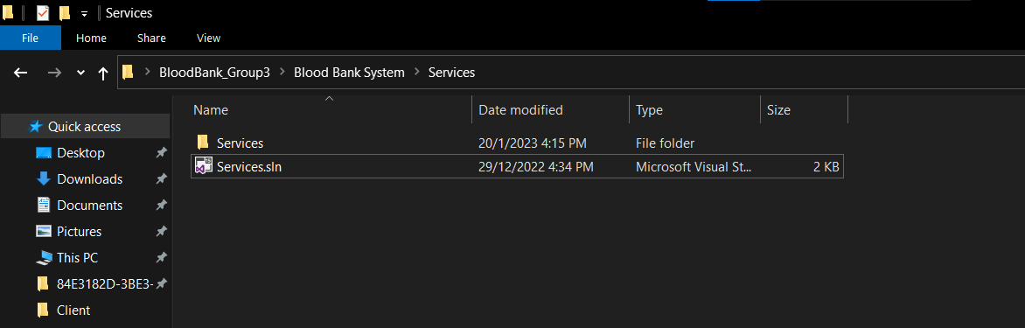

* **Step 2 :** Change login and password of sql server

**1 Open file appsettings.**json



**2 Change uid and pwd**



* **Step 3 :**Add migration :

1. Open Package Manager Console

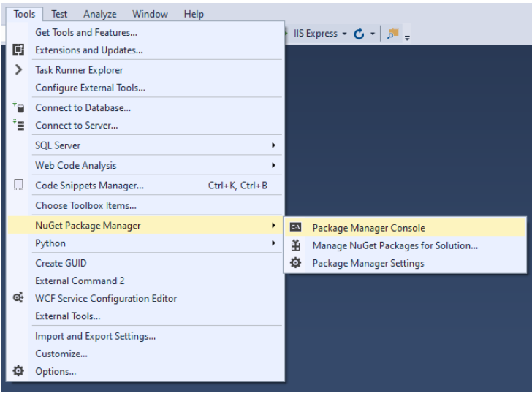

2. Type the following commands in order

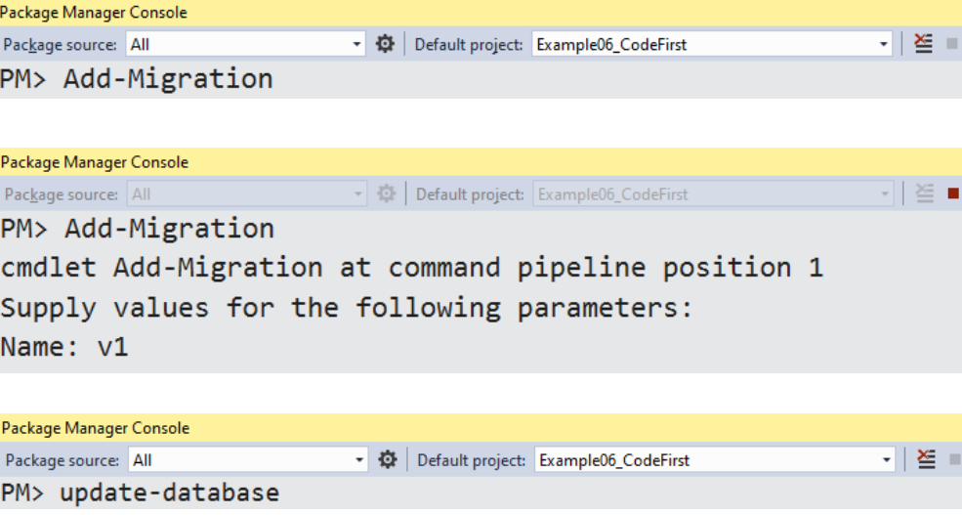

**Success :**



**- Step 3 :** Open Sql Server 2014.

Create Database DataSem3 Success

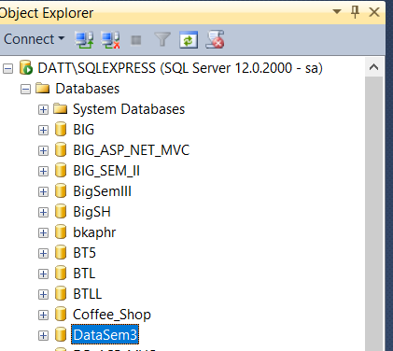

Insert value to DataSem3

* Open File SqlBloodBank.sql

Click Execute !

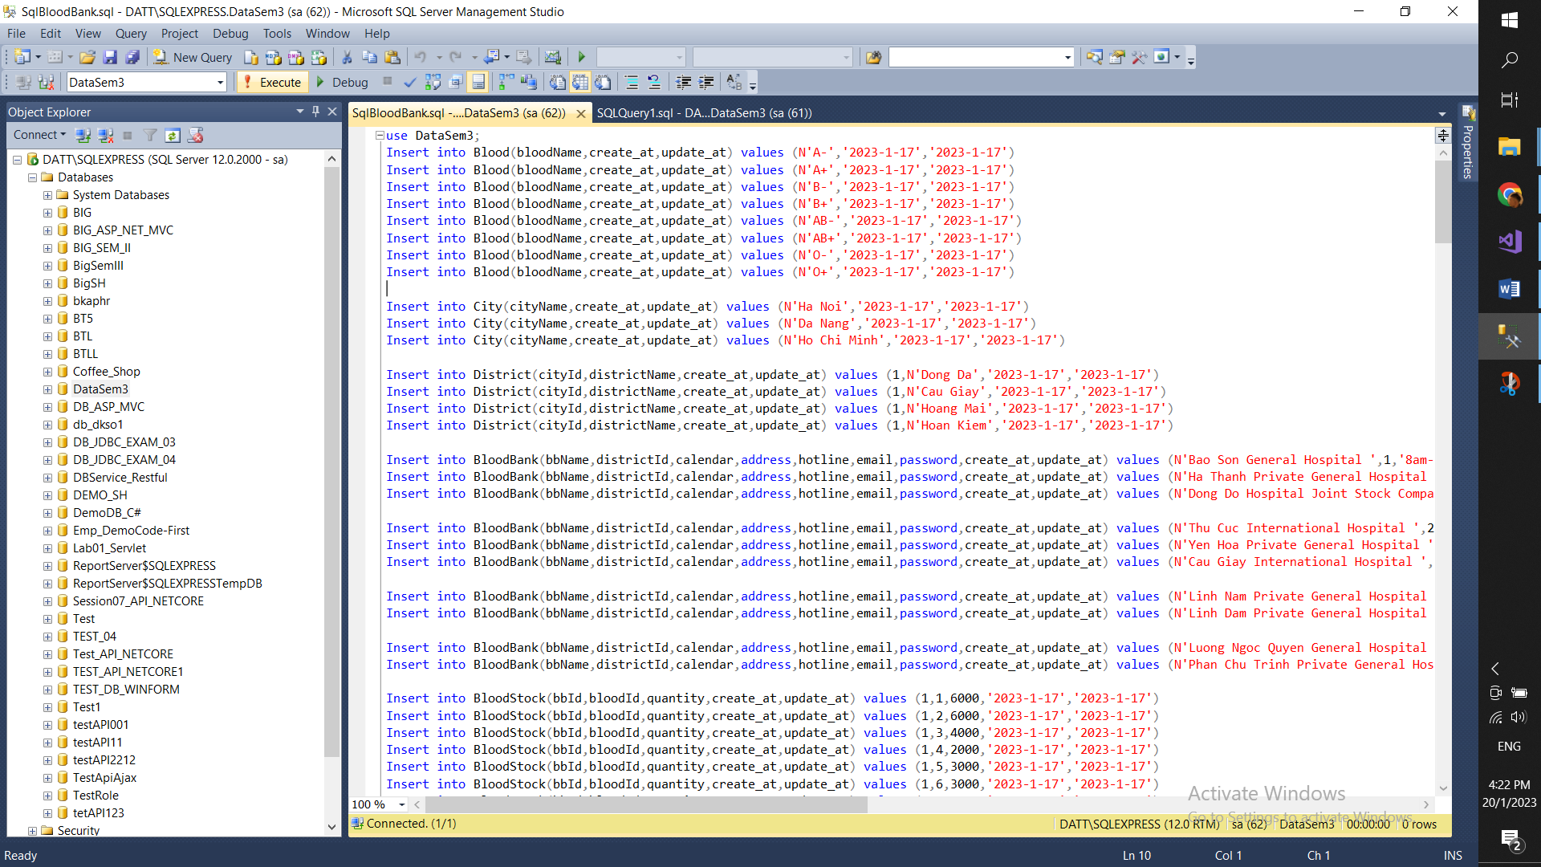

**Start browse web**

* **Step 1 :** Open Blood Bank System à Client à Client.sln

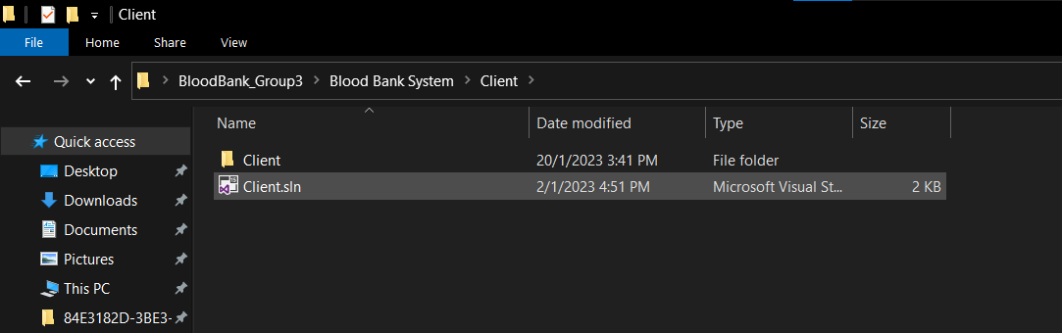

* **Step 2 : Run 2 project Services.sln and Client .sln at the same time**
* The Main Page: 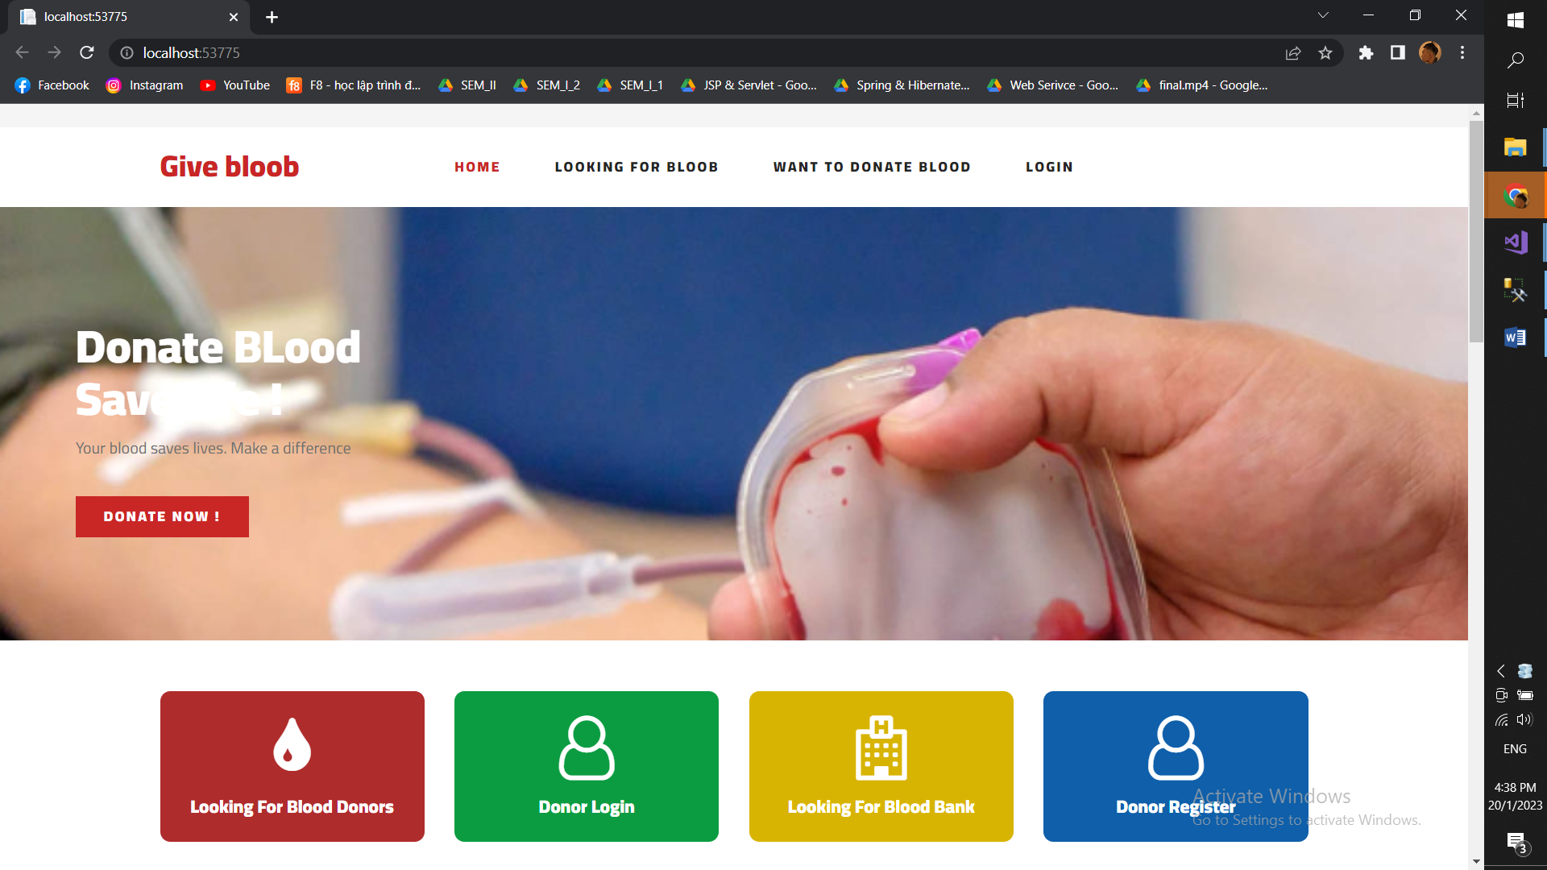
* The Admin Page: 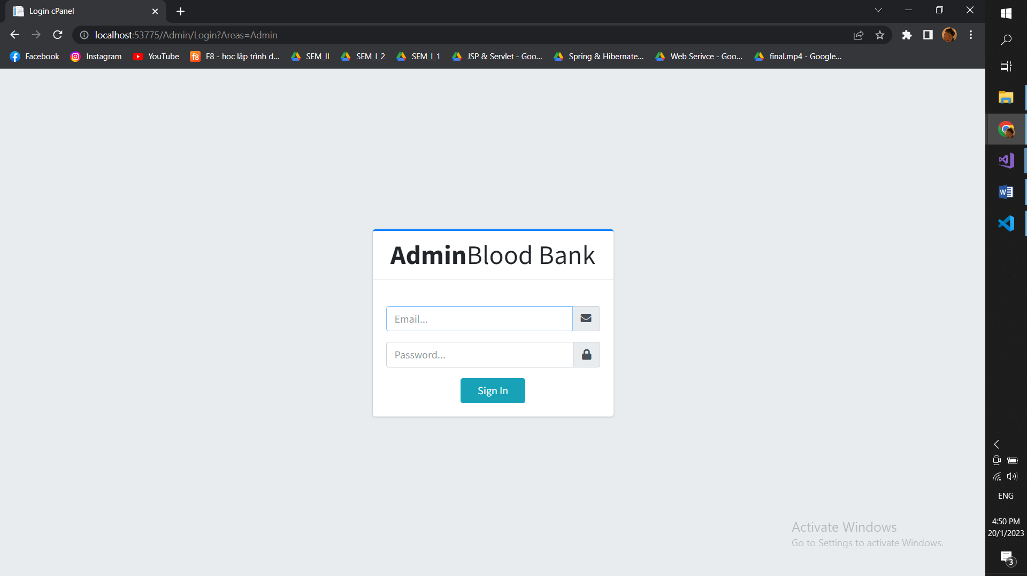
* The Blood Bank Page:

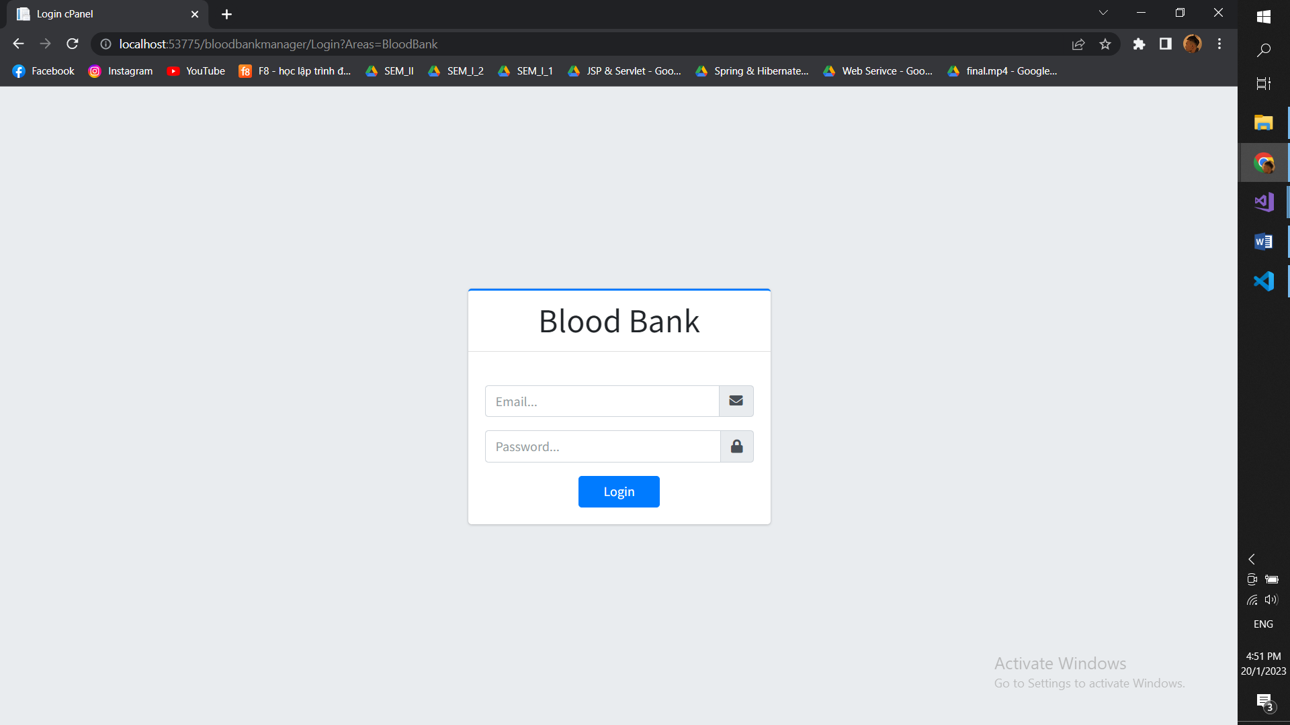

* **Login system** :
* Admin :
* Email : admin@gmail.com
* Password : 123456
* Blood Bank:
* Email: baoson@gmail.com
* Password: 123456
* Blood Donor:
* Email: duchai@gmail.com
* Password: 123456

**THE END**